E-COMMERCE SALES ANALYSIS
- Project Analysis:
This project analyzes E-Commerce Sales Analysis using transactional data from Wayfair dataset across various product categories. The goal is to uncover insights into spending patterns, customer segments, product preferences, and customer behavior to guide strategic business decisions.
- Dataset Summary:
- CSV Files: 4
- Total Rows: 28,543 across all four files
- Total Columns: 21 across all four files
- Dataset Files:
  - customers.csv – Customer information, including signup date, state, and acquisition channel.
  - orders.csv – Order details, including order date, status, payment method, discount code, and shipping fee.
  - order_items.csv – Order-level product details, including product ID, quantity, unit price, and discount amount.
  - products.csv – Product information, including product name, category, list price, and unit cost.
- Key Features:
  - Customer information (Customer ID, Signup Date, State, Acquisition Channel)
  - Order details (Order ID, Order Date, Order Status, Payment Method, Shipping Fee)
  - Product and transaction details (Product ID, Product Name, Category, Quantity, Unit Price, Discount Amount)
  - Pricing information (List Price, Unit Cost)
- Missing Data: 8,033 missing values across two files: 199 missing values in the unit_price column of order_items.csv and 7,834 in the discount_code column of orders.csv.
- Duplicates: orders.csv has 38 duplicate values.
- Exploratory Data Analysis with Python:
We began with data preparation and cleaning in Python:
- Data Loading: Imported data through Pandas.
- Initial Exploration: Using df.info( ) to check structure and .describe( ) for summary statistics.

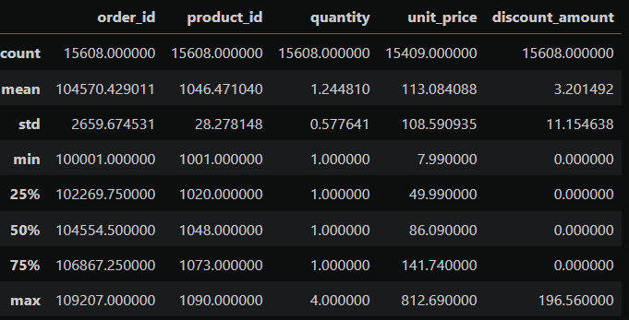

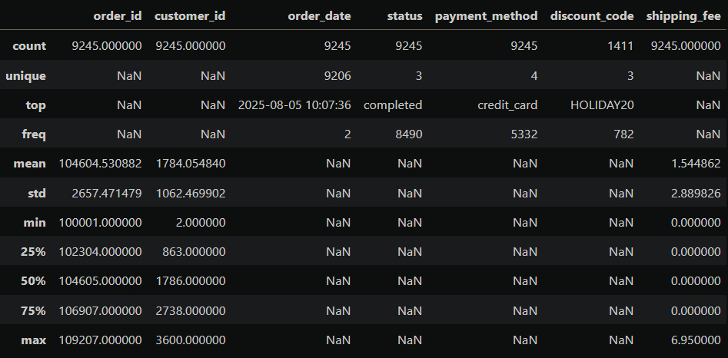

- Missing Data Handling: Checking for null values and imputed missing values in unit_price column and matching the null values of unit_price to list_price in products.csv.
- Data Inconsistency: Handled inconsistent values in category column in products.csv

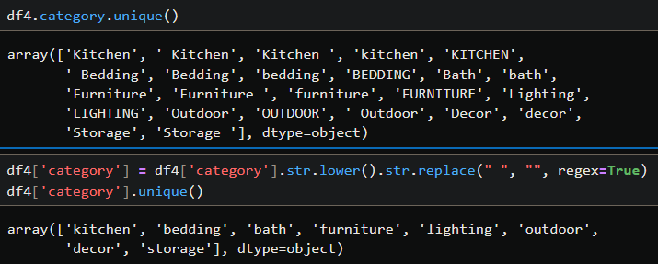

Replaced 7,834 blank values in the discount_code column of orders.csv with ‘No Discount’
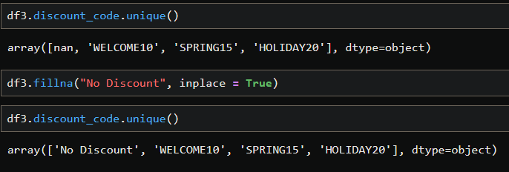

- Database Integration: Connected Python script to MySQL and loaded the cleaned DataFrame into the database for SQL Analysis

- Data Analysis with SQL:
We performed structured analysis in MySQL to answer key business questions:
- Revenue by acquisition channel: Customer acquisition channel, orders, orders per customer and their total purchase value.

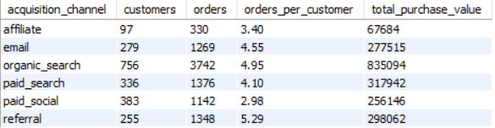

- Category performance: Calculated revenue by product category

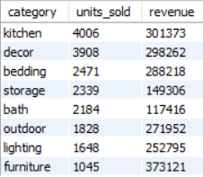

- Category vs. order status: Compare categories on how often their orders are returned or canceled.

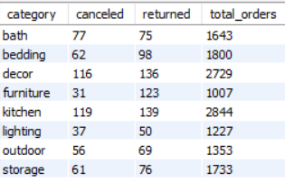

- 2024 vs. 2025: Compared monthly and annual revenue with year on year growth.

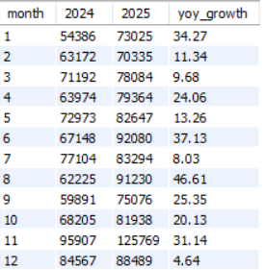

- Best-selling products: Rank products by units sold or eligible sales revenue, clearly stating which measure you use.

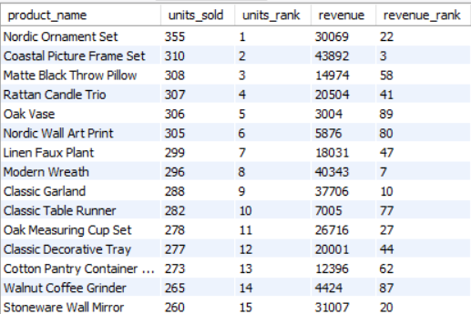
- Return and cancellation rates: Calculate the percentage of orders returned or canceled in each category.

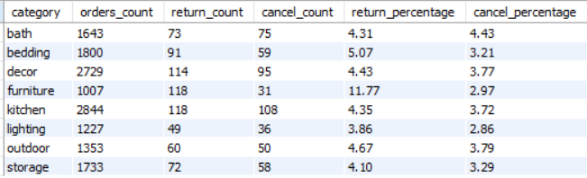

- Average order value (AOV): Eligible revenue divided by the number of eligible orders.

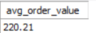

- Dashboard in Power BI:
Finally, we built an interactive dashboard in Power BI to present insights visually.

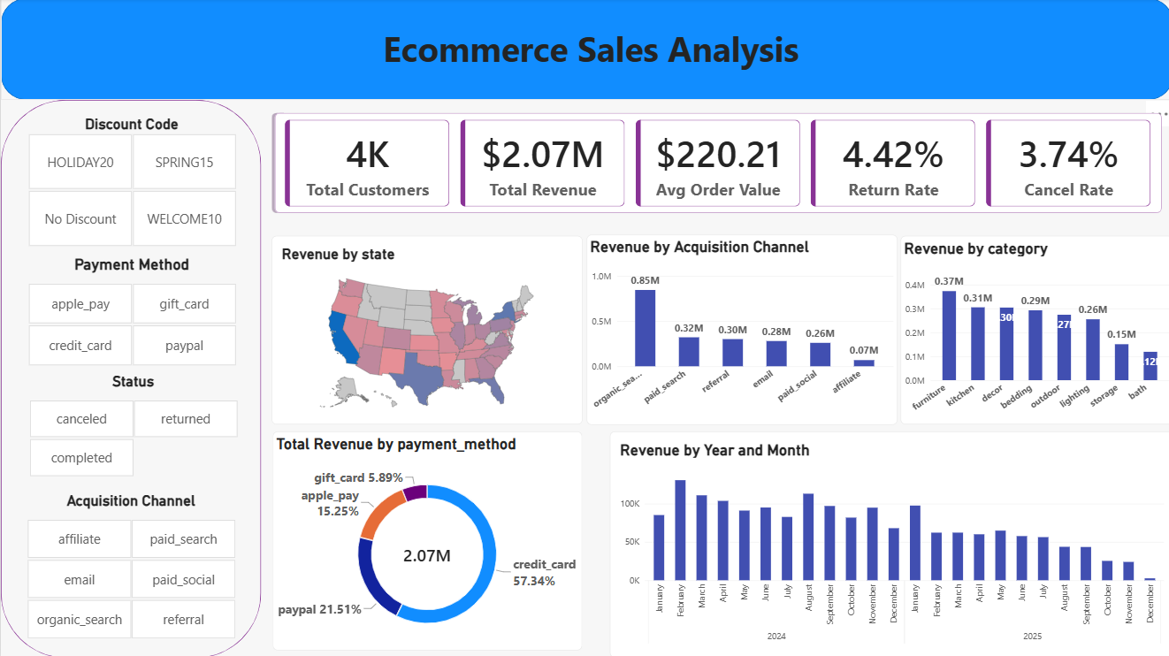

- Business Recommendation:
- Reduce Returns: Focus on Furniture, Bedding, and Outdoor categories, which have the overall high return rate.
- Reduce Cancellations: Investigate Bath first, followed by Outdoor and other categories with elevated cancellation rate.
- Optimize Acquisition Channels: Investigate repeat-purchase behaviour and customer value for Paid Social and Affiliate campaigns before reallocating marketing spend.
- Increase Sales: Investigate low unit sales in Furniture, Lighting, Outdoor, Bath, and Storage.
- Product Positioning: Highlight top-rated and best-selling products in campaigns.

